**Taboola Setup Guide**

v1.3

1. Shopify Customer Event

* Add a custom pixel, and insert the script provided by Taboola
* Shopify Settings > Customer events > Add custom pixel

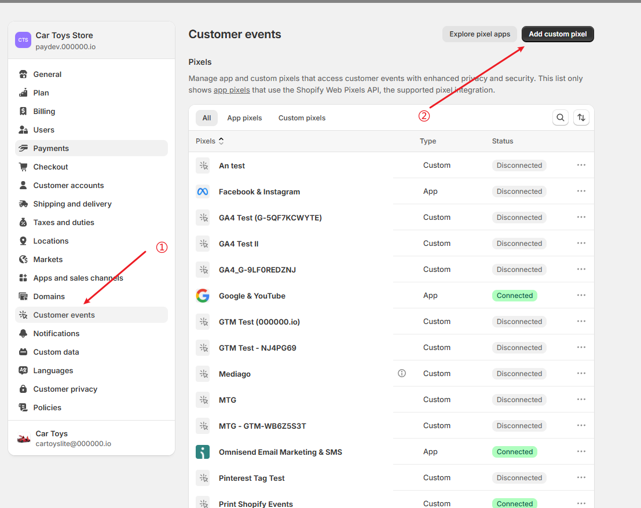

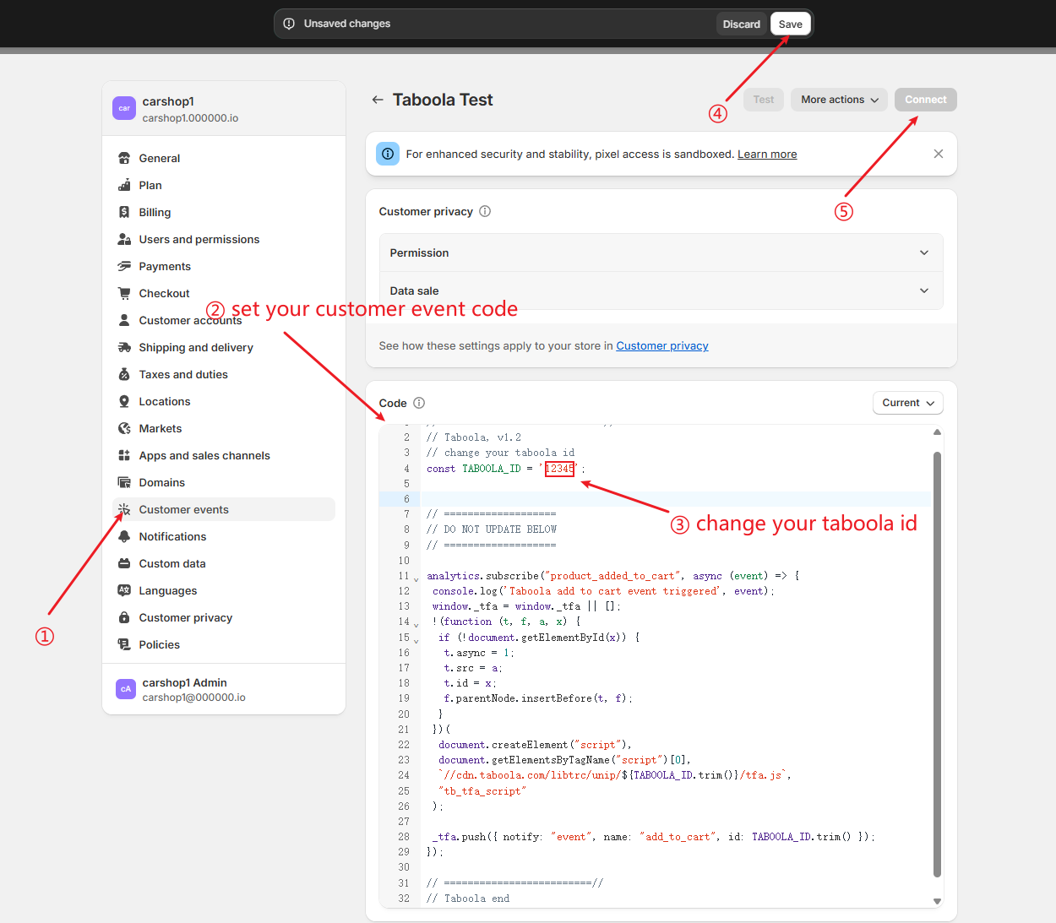

* Customer events show status is Connected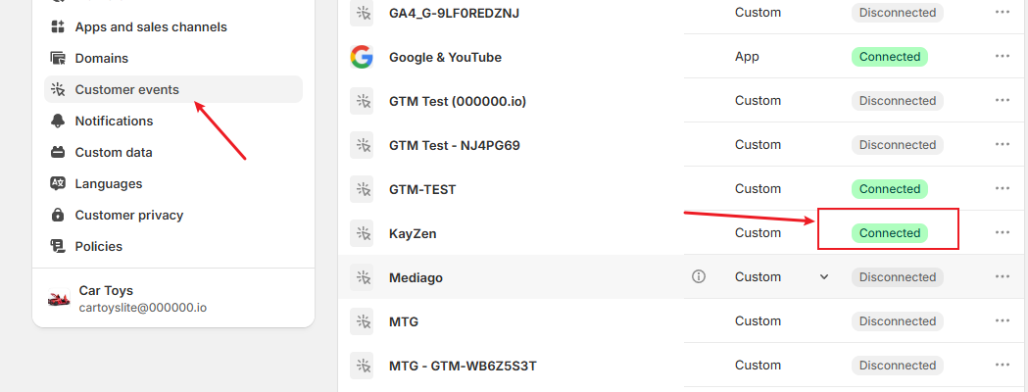

2. Shopify Theme

* Online Store > Themes > Select your theme > Edit code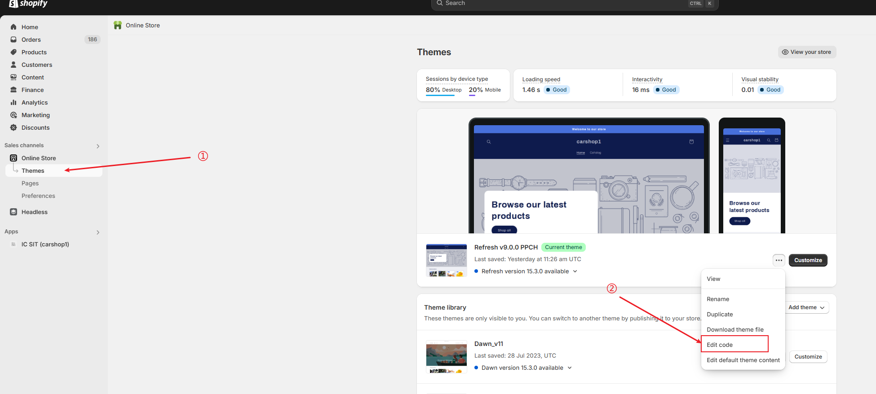
* Change your taboola id

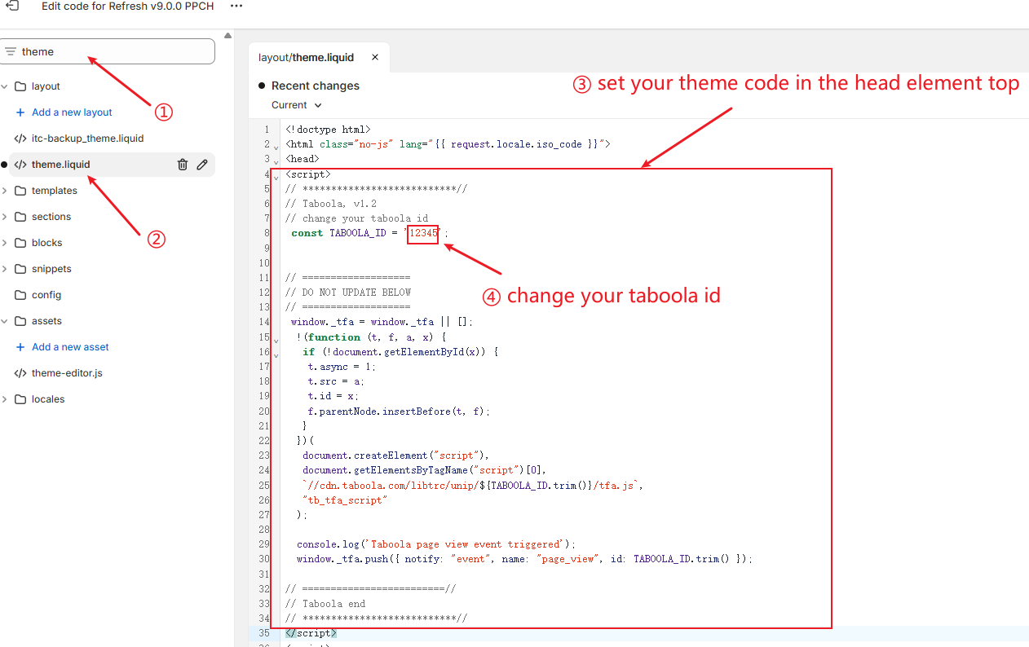

3. Intercart Extension Code  
Intercart app > More > Integrations > Extension Code

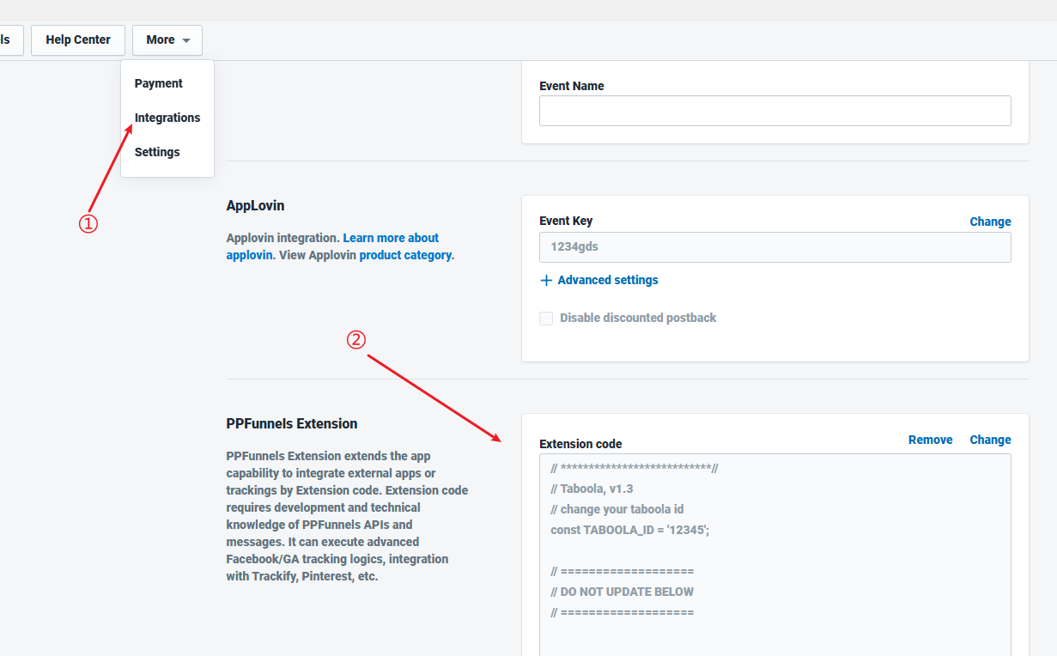

4.Test Procedures

4.1. Open Funnels >Preview Funnel 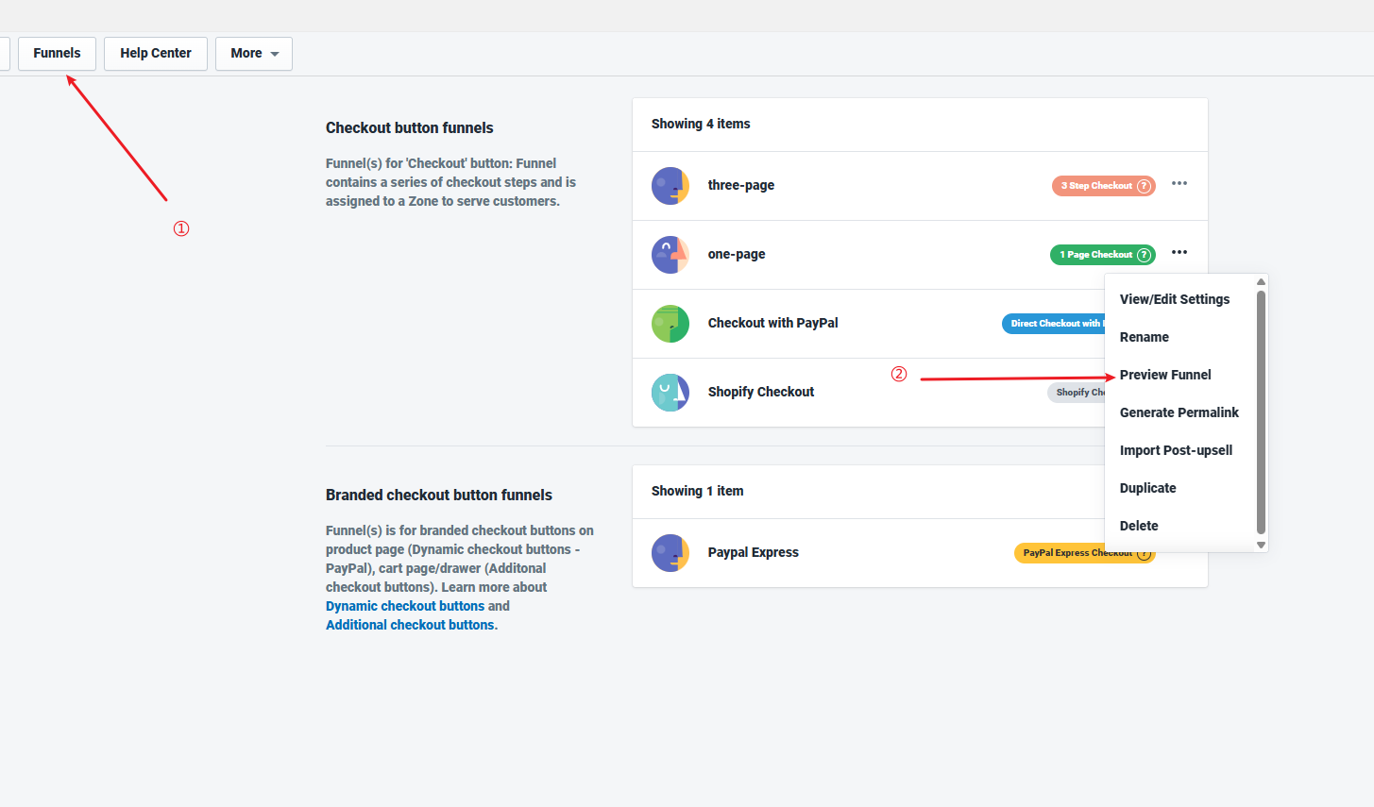

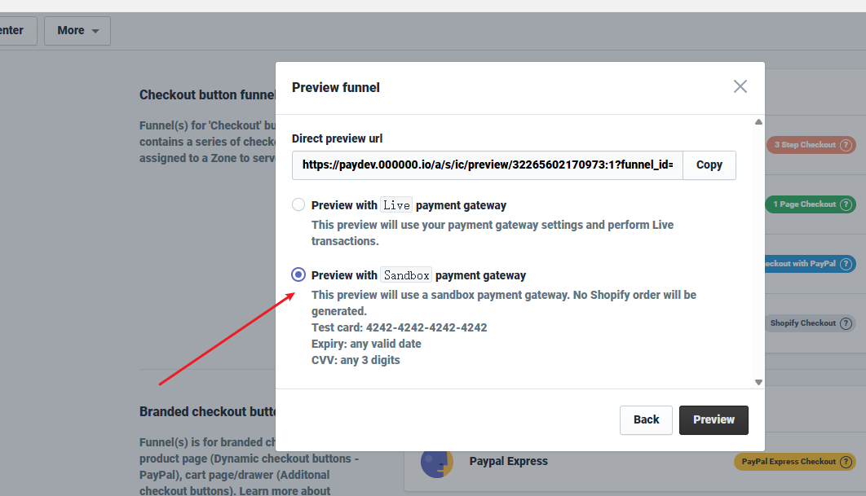

4.2. Open Chrome > Developer Tools > Console

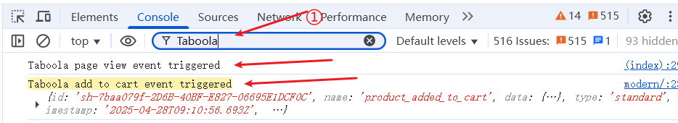

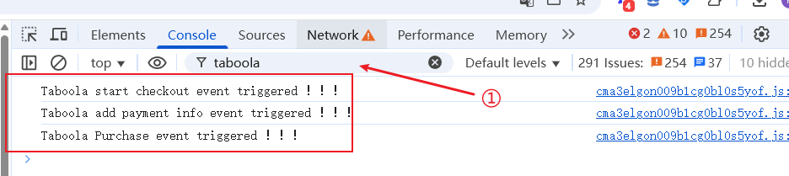

4.3. Open Chrome > Developer Tools > Network

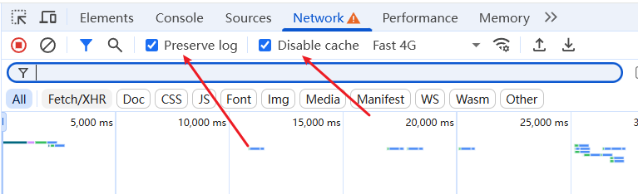

4.4. Purchase Order > Filter taboola keyword

